|  |  |
| --- | --- |
|  | |
| Data Advanced Data Analytics  CA TWO | |
| Module code : B8IT109 | |
| Ciaran Finnegan  Student No : 10524150  07/06/2020 |  |
|  |  |

Table of Contents

1 Question One 3

1.1 Question 1 – from PDF 3

1.2 Output From RStudio Cloud Console 3

2 Question Two 4

2.1 Question 2 – from PDF 4

2.2 Output from RStudio Cloud Console 4

3 Question Three 5

3.1 Question 3 – from PDF 5

3.2 Output from RStudio Cloud Console 5

4 Question Four 6

4.1 Question 4 – from PDF 6

4.2 Output from RStudio Cloud Console 7

# Question One

## Question 1 – from PDF

Use in-built dataset ‘airquality’,

a) explore the general feature of dataset using appropriate R functions.

(**5 Marks**)

b) perform data cleansing if required. (**5 Marks**)

c) consider ‘Temp’ attributes and compute the central and variational measures. (**10 Marks**)

d) apply boxplot technique to detect outlier of ‘wind’ attribute if any.

(**10 Marks**)

**(Total: 30 Marks)**

## Output From RStudio Cloud Console

To follow...

# Question Two

## Question 2 – from PDF

Use dataset available on http://users.stat.ufl.edu/~winner/data/nfl2008_fga.csv , then:

(a) Train the model using 80% of this dataset and suggest an appropriate GLM to model **homekick** to **togo, ydline** and **kicker** variables.

**(5 Marks)**

(b) Specify the significant variables on **homekick** at the level of 𝛼=0.05, and estimate the parameters of your model.

**(5 Marks)**

(c) Predict the test dataset using the trained model. **(5 Marks)**

(d) Provide the confusion matrix and obtain the probability of correctness of predictions. **(10 Marks)**

(Total: 25 Marks)

## Output from RStudio Cloud Console

To follow..

# Question Three

## Question 3 – from PDF

Using Yahoo Finance API, select a specific stock market price, apply time series analysis, consider ***‘close price’*** as your time series variable:

1. Validate the assumptions using graphical visualization. (5 Marks)
2. Fit the optimized model for ‘***close price’*** and provide the coefficient estimates for the fitted model. **(5 Marks)**
3. What is the estimated order for AR and MA? (5 Marks)

(d) Forecast h=10 step ahead prediction of ***‘close price’*** on the plot of the original time series. **(10 Marks)**

**(Total: 25 Marks)**

## Output from RStudio Cloud Console

## CA Two Advanced Data Analytics : Module Code B8IT109

## Student Name : Ciaran Finnegan

## Student Number : 10524150

## June 2020

## Question Three

## References used to call Yahoo Finance API

## http://statmath.wu.ac.at/~hornik/QFS1/quantmod-vignette.pdf

## https://stackoverflow.com/questions/26666254/retrieve-monthly-adjusted-stock-quotes-using-the-quantmod-package-in-r

###########################################################################

## Using Yahoo Finance API, select a specific stock market price, apply

time series analysis, consider ‘close price' as your time series variable:

###########################################################################

# 'Quantmod' Package required to access Yahoo Finance API

library(quantmod)

library(forecast)

# Library to plot time series to check for normality

library(ggpubr)

# Create a data structure that contains stock quote objects

ETF_Data <- new.env()

# Assign dates to set range for daily stock closing prices.

# This range of values over 13 months is set to be large enough for

# accurate forecasting but not too large to degrade the quality of the

# graph visuals.

sDate <- as.Date("2016-12-01") # Start date for time series

eDate <- as.Date("2018-01-01") # End date for time series

# Use the stock price data over the given period of time (above) for chosen company

# This code is written to allow the selection of different company stock

Prices # to compare trends and choose different time series.

# The stock chosen is the AIG (American International Group) for the year

2017

ticker_symbol = "AIG" # AIG

# Alternative company stocks - not used.

#ticker_symbol = "IBM" # International Business Machines

#ticker_symbol = "UA" # Under Armour, Inc

# Invoke 'getSymbols' function to retrieve to stock price data over the

time period for the chosen company through the Yahoo Finance API

getSymbols(ticker_symbol, env=ETF_Data, from=sDate, to=eDate, src = "yahoo", symbol.lookup = TRUE)

[1] "AIG"

# Load a dataset with the time series of the chosen company stock prices

CompanyStockPrices = get(ticker_symbol, envir = ETF_Data)

# Review the layout (head and tail) of the stock price information in

dataset

head(CompanyStockPrices)

AIG.Open AIG.High AIG.Low AIG.Close AIG.Volume AIG.Adjusted

2016-12-01 63.66 64.15 63.60 64.11 5942700 58.60310

2016-12-02 64.09 64.20 63.69 63.75 5651000 58.27402

2016-12-05 64.14 64.22 63.83 64.22 4706000 58.70365

2016-12-06 64.21 64.36 63.76 64.20 4942600 58.97925

2016-12-07 64.29 64.99 64.21 64.92 5113100 59.64070

2016-12-08 64.98 66.10 64.80 65.82 5196500 60.46751

tail(CompanyStockPrices)

AIG.Open AIG.High AIG.Low AIG.Close AIG.Volume AIG.Adjusted

2017-12-21 60.25 60.67 60.02 60.08 4941500 56.34938

2017-12-22 60.27 60.36 59.11 59.31 4266300 55.62718

2017-12-26 59.22 59.79 59.19 59.43 2358300 55.73974

2017-12-27 59.29 59.56 59.19 59.54 2841400 55.84291

2017-12-28 59.70 60.02 59.44 60.00 2373000 56.27434

2017-12-29 59.97 60.21 59.58 59.58 2837600 55.88041

# Consider ‘close_price' as my time series variable in the solution to this question

# I use the quantmod function 'Cl' to isolate the time series for closing

prices

close_price = Cl(CompanyStockPrices)

# Review initial and final records in 'close_price' time series

head(close_price)

AIG.Close

2016-12-01 64.11

2016-12-02 63.75

2016-12-05 64.22

2016-12-06 64.20

2016-12-07 64.92

2016-12-08 65.82

tail(close_price)

AIG.Close

2017-12-21 60.08

2017-12-22 59.31

2017-12-26 59.43

2017-12-27 59.54

2017-12-28 60.00

2017-12-29 59.58

###########################################################################

###########################################################################

###########################################################################**## Q.3 (Part a)**

## Using Yahoo Finance API, select a specific stock market price, apply

time series analysis, consider ‘close price' as your time series variable:

##(a) Validate the assumptions using graphical visualization.

## Run functions to look at the structure of the closing price dataset for our chosen stock

View(close_price)

## <Screen shot of 'View' output>

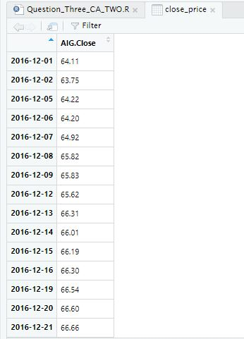

#<Output.. of str function on 'xts' object>

str(close_price)

An ‘xts’ object on 2016-12-01/2017-12-29 containing:

Data: num [1:272, 1] 64.1 63.8 64.2 64.2 64.9 ...

- attr(*, "dimnames")=List of 2

..$ : NULL

..$ : chr "AIG.Close"

Indexed by objects of class: [Date] TZ: UTC

xts Attributes:

List of 2

$ src : chr "yahoo"

$ updated: POSIXct[1:1], format: "2020-06-07 16:32:33"

## Invoke the 'ts' function on the 'close_price' time series.

T <- ts(close_price, frequency = 1)

## Generate the plot of the time series variable- the range represents the closing prices extracted from the time range of data (frequency = 1 so

every daily closing price is plotted).

plot(T)

## <Plot(T)>

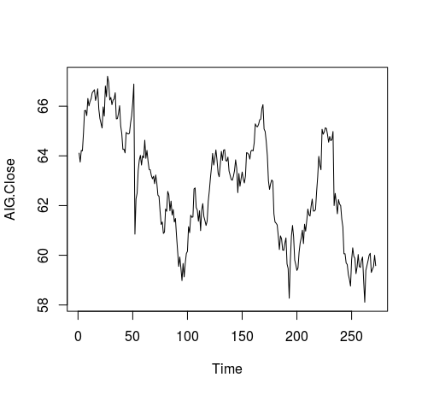

## We can see that the time series is not particularly stationary in terms of mean or variance

## We apply 'diff' and 'log' functions to smooth out the graph plot

## Apply 'diff' function

tssdiff=diff(T) # Stationary in mean

plot(tssdiff)

## <Diff plot graph>

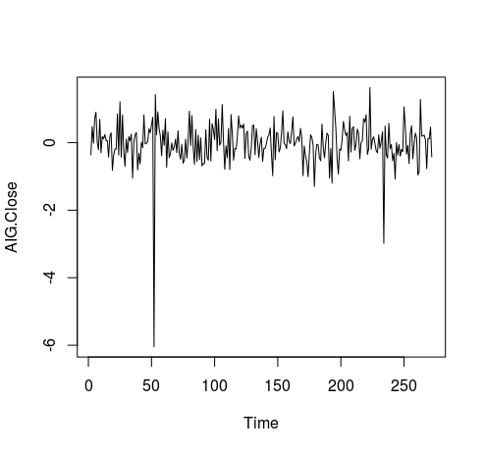

## The plot of 'diff' is more stationary in mean, with an average

approximately around zero.

## Apply log function, then applying 'diff', to achieve a stationary

visualisation in mean and variance

tssdifflg = diff(log(T))

plot(tssdifflg)

## <Log/Diff Plot Graph>

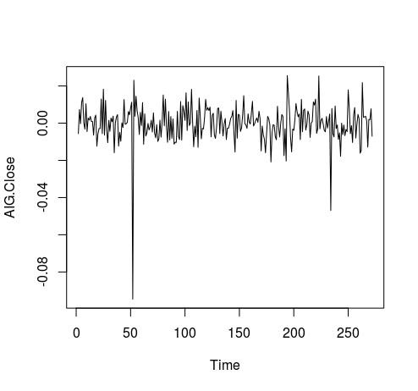

## This graph shows mean as approximately stationary and the variance also stationary between -0.02 and 0.02, apart from a few outliers

## ------------------------------------------------------------------------

## Also - run ggqqplot to graphing the data and show level of normality in the data set

## ------------------------------------------------------------------------

ggqqplot(T)

## <ggqqlog Plot Graph>

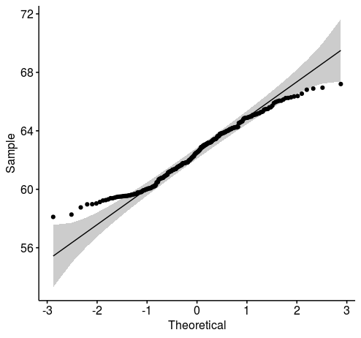

###########################################################################

**## Q.3 (Part b)**

## Fit the optimized model for ‘close price’ and provide the coefficient

estimates for the fitted model.

## To compute optimised coefficient estimates for fitted model we have two approaches :-

## 1:- Apply 'acf' and 'pacf' to get estimation of order, and also estimate parameters.

## 2:- Apply ARIMA manually

## 3:- Apply Auto ARIMA

## 4:- Select the model with the lowest AiC (Akaike Information Criterion) value and use those coefficient values

## It is necessary to apply both methods (manual and automatic) and see

which one has a lower AIC, then determine that method is optimised.

## Try and find as low a value of AIC as possible

## 1 - Apply 'acf' and 'pacf' to get estimations of 'q' and 'p'

## acf = autocorrelation function. Gives us the estimation for 'q'

acf(tssdifflg)

## <acf Plot Graph>

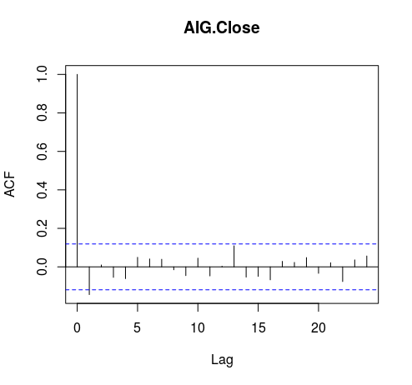

## There are two initial lags outside the boundary, therefore q = 2. (Above or below boundary line is not important).

## pacf = partial autocorrelation function. Gives is the estimation for 'p'

pacf(tssdifflg)

## <pacf Plot Graph>

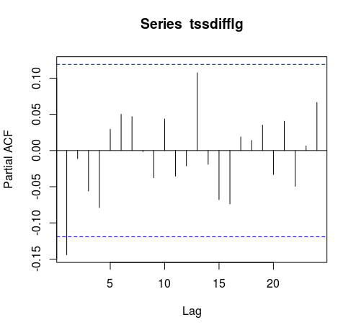

## One initial lag is outside are outside the bounds, therefore p = 1

## Now use 'arima' function to fit a manual ARIMA; p = 1, (1 diff used), q = 2. The original time series with closing price is used.

## ARIMA (p,d,q) Model : Using original time series 'T'

## Parameter Estimation

manual.fit <- arima(T, c(1,1,2)) # Fitted Model

## Display value of 'manual.fit'

manual.fit

Call:

arima(x = T, order = c(1, 1, 2))

Coefficients:

ar1 ma1 ma2

-0.9986 0.8525 -0.1420

s.e. 0.0058 0.0621 0.0616

sigma^2 estimated as 0.4067: log likelihood = -262.82, aic = 533.63

## With p = 1, we see one value for the 'ar1' coefficient

## With q = 2, we see two values for the 'ma' (moving average) coefficients

## The values just under the 'ar1', 'ma1', and 'ma2' headings are the

Estimation of parameters

Coefficients:

ar1 ma1 ma2

-0.9986 0.8525 -0.1420

## We can see the aic (Akaike Information Criterion) value = 533.63

## Next we need to apply 'auto.arima' to generate a fitted model

## 'seasonal' = F - time series does not have a seasonality trend

auto.fit <- auto.arima(T, seasonal = FALSE)

auto.fit

Series: T

ARIMA(0,1,1)

Coefficients:

ma1

-0.1502

s.e. 0.0611

sigma^2 estimated as 0.4101: log likelihood=-263.27

AIC=530.54 AICc=530.58 BIC=537.74

## AIC = 530.54

## 'seasonal' = F - time series does not have a seasonality trend

auto.fit.T <- auto.arima(T, seasonal = TRUE)

auto.fit.T

Series: T

ARIMA(0,1,1)

Coefficients:

ma1

-0.1502

s.e. 0.0611

sigma^2 estimated as 0.4101: log likelihood=-263.27

AIC=530.54 AICc=530.58 BIC=537.74

# 'seasonal' flag makes no difference to result

## AIC = 530.54

## Automated coefficient are lower as 533.63 (Manual) > 530.54 (Auto,

non seasonal). Therefore Auto ARIMA is better than manual fitting.

**## Q.3 (Part c)**

## What is the estimated order for AR and MA?

auto.fit

Series: T

ARIMA(0,1,1)

Coefficients:

ma1

-0.1502

s.e. 0.0611

sigma^2 estimated as 0.4101: log likelihood=-263.27

AIC=530.54 AICc=530.58 BIC=537.74

## The best model shows Series: T ARIMA(0,1,1)

## Therefore the estimated order for **AR is p = 0, and MA is q = 1**

**## Q.3 (Part d)**

## Forecast h=10 step ahead prediction of wage on the plot of the

## original time series.

# The best model to use is the auto fitting - as determined in the analysis in the previous steps in the question.

auto.fcast <- forecast(auto.fit, h = 10) # Prediction for 10 step ahead

## Plot this forecast

plot(auto.fcast)

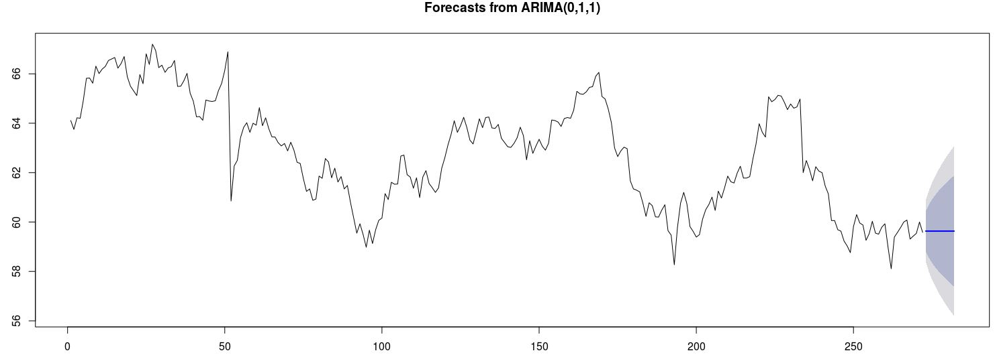

###########################################################################

## The forecast graph is still not particularly useful. Howeveer, if we

change the 'seasonal' = T paramer in the auto.arima function then the time series will incorpoate a seasonality trend BUT it is necessary to 'force'

the closing price time series into a mult-seasonal time series in order to pick up the time pattern in the data.

#

## Set up mult-seasonal time series to match a working day period of 13 months (as defined when the stock data was first extracted via the Yahoo API)

stockSTS <- msts(T,seasonal.periods=c(5,270))

## Set 'D' parameter in auto.arima function so that the seasonal component in the data will be picked up

auto.fitT <- auto.arima(stockSTS, D=1, seasonal = TRUE)

## Check the aic value

auto.fitT

auto.fcastT <- forecast(auto.fitT, h = 10) # Prediction for 10 steps ahead

## Plot this forecast

plot(auto.fcastT)

# Forecast is more realistic looking...

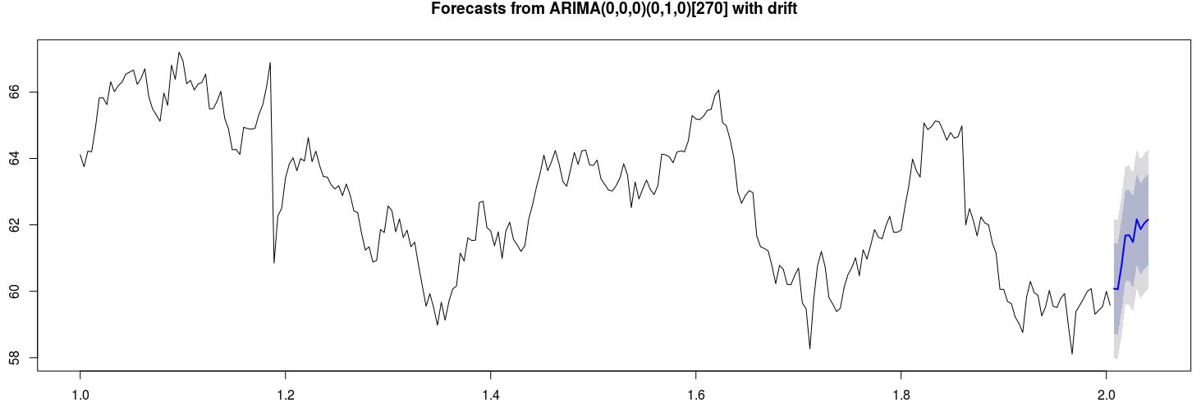

# Question Four

## Question 4 – from PDF

Use dataset available on http://users.stat.ufl.edu/~winner/data/nfl2008_fga.csv

1. Use LDA to classify the dataset into few classes so that at least 90% of information of dataset is explained through new classification. (**Hint**: model the variable “**qtr”** to variables “**togo**”, “**kicker**”, and “**ydline**”). How many LDs do you choose? Explain the reason.

**(5 Marks)**

*2.* Apply PCA, and identify the important principle components involving at least 90% of dataset variation. Explain your decision strategy? Plot principle components

versus their variance (**Hint**: to sketch the plot use the Scree plot). **(5 Marks)**

3. Split the dataset into two sets of variables so that **X**=( togo,kicker,ydline) and **Y**=( distance, homekick). Apply canonical correlation analysis to find the cross-correlation between **X** and **Y**. What is the correlation between ***ydline*** and ***distance***? **(5 Marks)**

4. Use K-means clustering analysis to identify the most important classes. How many classes do you select? Why?

**(6 Marks)**

**(Total: 20 Marks)**

## Output from RStudio Cloud Console

> ## CA Two Advanced Data Analytics : Module Code B8IT109

> ## Student Name : Ciaran Finnegan

>

> ## Student Number : 10524150

>

> ## June 2020

>

>

**> ## Question Four - LDA, PCA, K-Means, Canonical Correlation**

>

> ## Use dataset available on http://users.stat.ufl.edu/~winner/data/nfl2008_fga.csv

> ## Perform initial data load, analysis, and clean up operations before

Starting Question 4 solution

>

>

>

> ## Load MASS library to use LDA function

> library(MASS)

> library(CCA)

>

> # Load 'factoextra' for visualization - Scree plot

> #install.packages("factoextra")

> library(factoextra)

>

>

>

> ## Read in the NFL dataset

> link='http://users.stat.ufl.edu/~winner/data/nfl2008_fga.csv'

> datasetNFL=read.csv(link)

> ## Brief Review of number of rows, head and tail of dataset records

> ## the and structure of dataset

> nrow(datasetNFL)

[1] 1039

> head(datasetNFL)

GameDate AwayTeam HomeTeam qtr min sec kickteam def down togo kicker ydline name distance homekick kickdiff timerem offscore

1 20081130 IND CLE 1 47 2 IND CLE 4 11 15 12 A.Vinatieri 30 0 -3 2822 0

2 20081005 IND HOU 1 54 47 IND HOU 4 3 15 28 A.Vinatieri 46 0 0 3287 0

3 20081228 TEN IND 1 45 20 IND TEN 4 3 15 10 A.Vinatieri 28 1 7 2720 7

4 20081012 BAL IND 1 45 42 IND BAL 4 1 15 19 A.Vinatieri 37 1 14 2742 14

5 20080907 CHI IND 1 50 56 IND CHI 4 21 15 21 A.Vinatieri 39 1 0 3056 0

6 20081116 HOU IND 1 50 43 IND HOU 4 7 15 22 A.Vinatieri 40 1 -3 3043 0

defscore season GOOD Missed Blocked

1 3 2008 1 0 0

2 0 2008 1 0 0

3 0 2008 1 0 0

4 0 2008 1 0 0

5 0 2008 1 0 0

6 3 2008 1 0 0

> tail(datasetNFL)

GameDate AwayTeam HomeTeam qtr min sec kickteam def down togo kicker ydline name distance homekick kickdiff timerem offscore

1034 20081102 TB KC 5 -5 27 TB KC 4 1 36 16 M.Bryant 34 0 0 -273 27

1035 20081102 GB TEN 5 -6 41 TEN GB 3 2 37 23 R.Bironas 41 1 0 -319 16

1036 20081211 NO CHI 5 -3 19 CHI NO 2 13 7 18 R.Gould 35 1 0 -161 24

1037 20081222 GB CHI 5 -4 33 CHI GB 3 10 7 20 R.Gould 38 1 0 -207 17

1038 20081116 PHI CIN 5 -15 13 CIN PHI 4 5 8 29 S.Graham 47 1 0 -887 13

1039 20081019 NYJ OAK 5 -13 35 OAK NYJ 4 11 28 39 S.Janikowski 57 1 0 -745 13

defscore season GOOD Missed Blocked

1034 27 2008 1 0 0

1035 16 2008 1 0 0

1036 24 2008 1 0 0

1037 17 2008 1 0 0

1038 13 2008 0 1 0

1039 13 2008 1 0 0

> str(datasetNFL)

'data.frame': 1039 obs. of 23 variables:

$ GameDate: int 20081130 20081005 20081228 20081012 20080907 20081116 20081123 20081207 20081130 20090118 ...

$ AwayTeam: Factor w/ 32 levels "ARI","ATL","BAL",..: 14 14 31 3 6 13 14 16 16 24 ...

$ HomeTeam: Factor w/ 32 levels "ARI","ATL","BAL",..: 8 13 14 14 14 14 26 10 23 1 ...

$ qtr : int 1 1 1 1 1 1 1 1 1 1 ...

$ min : int 47 54 45 45 50 50 46 52 46 49 ...

$ sec : int 2 47 20 42 56 43 45 34 12 46 ...

$ kickteam: Factor w/ 32 levels "ARI","ATL","BAL",..: 14 14 14 14 14 14 14 16 16 24 ...

$ def : Factor w/ 32 levels "ARI","ATL","BAL",..: 8 13 31 3 6 13 26 10 23 1 ...

$ down : int 4 4 4 4 4 4 4 4 4 4 ...

$ togo : int 11 3 3 1 21 7 5 7 7 9 ...

$ kicker : int 15 15 15 15 15 15 15 18 18 29 ...

$ ydline : int 12 28 10 19 21 22 5 8 20 27 ...

$ name : Factor w/ 39 levels "A.Vinatieri",..: 1 1 1 1 1 1 1 2 2 3 ...

$ distance: int 30 46 28 37 39 40 23 26 38 45 ...

$ homekick: int 0 0 1 1 1 1 0 0 0 0 ...

$ kickdiff: int -3 0 7 14 0 -3 0 0 -3 -7 ...

$ timerem : int 2822 3287 2720 2742 3056 3043 2805 3154 2772 2986 ...

$ offscore: int 0 0 7 14 0 0 0 0 0 0 ...

$ defscore: int 3 0 0 0 0 3 0 0 3 7 ...

$ season : int 2008 2008 2008 2008 2008 2008 2008 2008 2008 2008 ...

$ GOOD : int 1 1 1 1 1 1 1 1 1 1 ...

$ Missed : int 0 0 0 0 0 0 0 0 0 0 ...

$ Blocked : int 0 0 0 0 0 0 0 0 0 0 ...

>

>

> ## Minor Clean up of NFL dataset

> sum(is.na(datasetNFL))

[1] 4

> datasetNFL <- na.omit(datasetNFL)

> sum(is.na(datasetNFL))

[1] 0

> nrow(datasetNFL) # Confirm rows after missing data removed = 1037

[1] 1037

>

>

**> ## Q. 4(Part 1)**

>

> ## Use LDA to classify the dataset into a small number of classes so that at least 90% of the information of the dataset is explained through new classification.

> ## (Hint: model the variable “qtr” to variables “togo”, “kicker”,

and “ydline”).

> ## How many LDs do you choose? Explain the reason.

>

>

>

> # Display the values for 'qtr'

> table(datasetNFL$qtr)

1 2 3 4 5

214 373 182 255 13

>

>

>

>

> ## Use LDA function to classify dataset. The output variable is 'qtr' and the input variables are > ##'togo', 'kicker', and 'ydline'.

> datasetNFL.lda <- lda(qtr~togo+kicker+ydline, data=datasetNFL)

> datasetNFL.lda

Call:

lda(qtr ~ togo + kicker + ydline, data = datasetNFL)

Prior probabilities of groups:

1 2 3 4 5

0.20636451 0.35969142 0.17550627 0.24590164 0.01253616

Group means:

togo kicker ydline

1 6.481308 19.64486 17.22897

2 6.973190 18.77212 19.30027

3 6.543956 19.96703 19.03297

4 6.792157 20.20000 18.53725

5 5.923077 22.61538 19.53846

Coefficients of linear discriminants:

LD1 LD2 LD3

togo 0.06665269 0.12498308 0.20996464

kicker -0.04134867 -0.06009657 0.05013225

ydline 0.07726467 -0.07173243 -0.02257770

Proportion of trace:

LD1 LD2 LD3

0.615 0.322 0.063

>

> ## Two LDs are required - LD1 and LD2 - to explain at least 90% of formation of the NFL dataset

> ## Reading values under the 'Proportion of trace:' output I can see...

> ## LD1 explains 61.5%. LD2 explains a further 32.2%. Hence LD1 and LD2

will explain 93.7 % together.

>

>

>

**> ## Q. 4(Part 2)**

>

> ## Apply PCA, and identify the important principle components involving

at least 90% of dataset variation.

> ## Explain your decision strategy?

>

> ## We only use the input variables for the PCA question.This analysis is a type of 'unsupervised' learning.

> ## Just focusing on raw data on 'togo', 'kicker', and 'ydline' from

> ## dataset and extracting PCs from the correlation matrix

>

> ## I could have used the cbind(datasetNFL$togo, datasetNFL$kicker, datasetNFL$ydline) function but I want to preserve the dataset column names

> datasetNFL2 = datasetNFL[10:12] # datasetNFL$togo, datasetNFL$kicker, datasetNFL$ydline

> fit <- princomp(datasetNFL2, cor = TRUE)

> summary(fit) # Print variance

Importance of components:

Comp.1 Comp.2 Comp.3

Standard deviation 1.146726 0.9998433 0.8278479

Proportion of Variance 0.438327 0.3332289 0.2284441

Cumulative Proportion 0.438327 0.7715559 1.0000000

>

>

> ## Looking at the 'Cumulative Proportion' output line we can see that

Comp1 captures 43.8% of dataset variation.

> ## Comp 1 and Comp2 togther capture 77.2% (approx) of dataset variation.

> ## However, all three components (Comp1, Comp2, Comp3) are important to

capture 90% of the dataset variation.

>

>

> ## Plot principle components versus their variance

> ## (Hint: to sketch the plot use the Scree plot).

>

> #

> ## Use function to extract loadings for factor analysis - small loadings are usually not printed.

> loadings(fit) # PC loadings

Loadings:

Comp.1 Comp.2 Comp.3

togo 0.707 0.707

kicker 0.999

ydline 0.706 -0.707

Comp.1 Comp.2 Comp.3

SS loadings 1.000 1.000 1.000

Proportion Var 0.333 0.333 0.333

Cumulative Var 0.333 0.667 1.000

>

> #

> ## Visualize eigenvalues (scree plot). Show the percentage of variances

explained by each principal component.

> fviz_eig(fit)

>

> # <Scree Plot Graph>

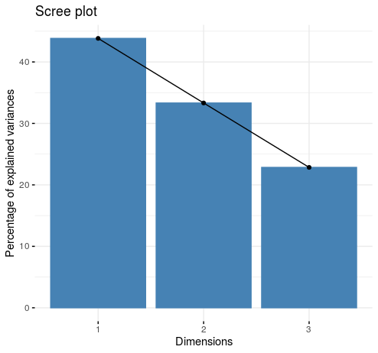

>

> #

> plot(fit, type = "lines") # Another Scree Plot view. A plot of variation

>

> #

> ## <Plot Graph>

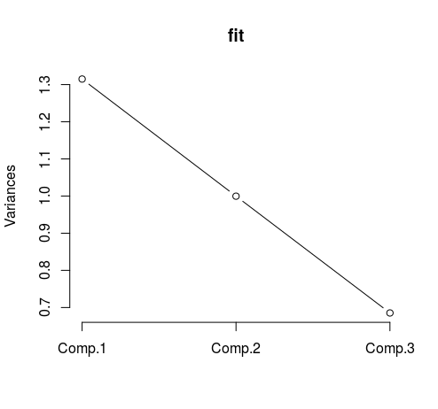

> ## Component 2 is just on or over the Variance value of '1' so I can

determine that Component 1 and 2 are the most important components to

consider.

> ## However, in order to meet the 90% level of variance requested in this question we still need to consider Component 3.

>

>

> biplot(fit) # Graph that shows two components and role of each variable

(relationship between components and variables)

>

> #

> # <BiPlot Graph>

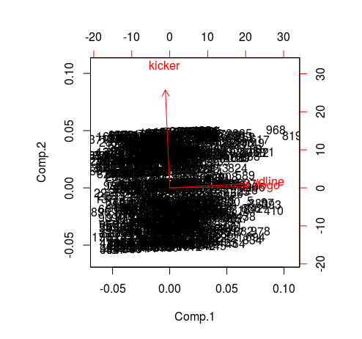

> ## For example, as you increase 'ydline' there is an noticeable increase in Component 1

> ## An increase in 'ydline' shows a very minor increase in Component 2

>

>

>

> #

> ## The Plots confirms that all three components are important to capture 90%.

> ## There is no 'bend' in the line indicating that higher components

contribute less to the capture of dataset variation

>

>

>

**> ## Q. 4(Part 3)**

>

> ## Split the dataset into two sets of variables so that

X=(togo, kicker, ydline) and Y=(distance, homekick).

> ## Apply canonical correlation analysis to find the cross-correlation

between X and Y.

>

>

> ## Set up 'X' variable

> X <- cbind(datasetNFL$togo, datasetNFL$kicker, datasetNFL$ydline)

>

> ## Set up 'Y' variable

> Y <- cbind(datasetNFL$distance, datasetNFL$homekick)

>

> ## Run 'cor' function to produce Correlation Matrix

> cor(X, Y)

[,1] [,2]

[1,] 0.315641454 -0.04838438

[2,] -0.001951722 -0.02363159

[3,] 0.998947222 0.04295427

>

>

> ## What is the correlation between 'ydline' and 'distance'?

>

> ## Read three down the X value and one across the Y value

> ## The correlation between 'ydline' and 'distance' is equal to

'0.998947222'

> ## This value shows a high level of correlation between the 'ydline' and 'distance' values

>

>

>

>

>

>

>

**> ## Q. 4(Part 4)**

>

> ## Use K-means clustering analysis to identify the most important classes.

> ## How many classes do you select? Why?

>

> ## Again consider the input variables. We use the 'datasetNFL2' dataset

because I want to just consider the 'togo', 'kicker', and 'ydline' input

variables.

>

>

>

> # Generate the plot K-Means clustering

> ## Write function for plot generation

> wssplot <- function(datasetNFL2, nc=10, seed=2343){

+

+ wss <- (nrow(datasetNFL2)-1) * sum(apply(datasetNFL2, 2, var))

+

+ for (i in 2 : nc){

+

+ set.seed(seed)

+ wss[i] <- sum(kmeans(datasetNFL2, centers = i)$withinss)

+

+ }

+

+ plot(1:nc, wss, type = "b", xlab = "Numbers of Clusters", ylab = "Within Groups Sum of Squares")

+

+

+ }

>

> # Invoke plot function

> wssplot(datasetNFL2, nc = 10)

> # Use a default of number of classes = 10 to start the analysis

>

> # <K-Mean Cluster Graph>

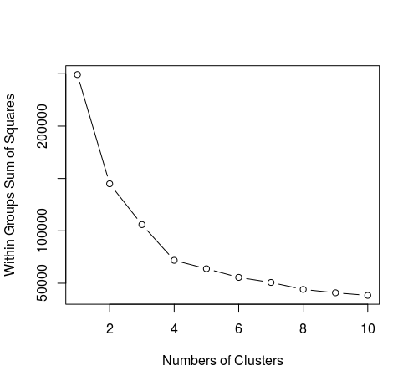

>

>

> #

> ## In the Cluster graph we can see a definite 'elbow' at Number of

Clusters = 4.

> ## After Cluster 4 the changes in variation are noticeably less

> ## Therefore the main cluster are clusters 1 through to cluster 4.

> ## We would select four classes as an answer to this question.

>

>

> ## K-Means : Clustering Analysis on NFL Dataset

> k.means.fit <- kmeans(datasetNFL2, 4) # k = 4, the number of classes in

type (see above)

> attributes(k.means.fit)

$names

[1] "cluster" "centers" "totss" "withinss" "tot.withinss" "betweenss" "size" "iter" "ifault"

$class

[1] "kmeans"

>

> ## Centroids(arithmetic mean)

> k.means.fit$centers

togo kicker ydline

1 5.268293 28.439024 10.22997

2 7.961373 30.841202 27.05579

3 5.952586 8.336207 10.53879

4 7.859649 10.536842 26.82807

>

> ## Cluster size - shows the breakdown of the number of datapoints in the NFL dataset into my chosen cluster grouping

> k.means.fit$size

[1] 287 233 232 285

>

> ## All value above sum to 1037, which is the size of the dataset (rows)